July 31, 2012


Traffic.511.org
Admin Site

Version 1.0

Prepared by:
SAIC
David Balmer


1000 Broadway, Suite 680
Oakland, CA 94612

Table of Contents

1 Overview 3
2 Promos 3
2.1 On the new Traffic website 3
2.2 On the My511 website 4
3 Database Changes and Data Format 5
3.1 Traffic Promo image data is published in JSON format (grouped by DisplayType) 5
4 Admin Site 6
5 Authentication 6
6 Admin Home Page 7
7 Promo Admin Page 7
7.1 Adding a new Promo 8
7.2 Date/Time Selection 8
7.3 Editing a Promo 9
7.4 Deleting a Promo 9
8 Loading images from the database 9
8.1 On the new Traffic website 9
8.2 On the My511 website 9
9 Deployment 10
9.1 Database Scripts 10
9.2 Website installation and configuration 10
9.2.1 For the new TrafficAdmin website 10
9.2.2 In TrafficCore XML Config file 10
10 References 10

Overview
New website to administer alerts and promos instead of using legacy admin site at http://traffic30/default.asp (promos) and http://my511.org (for promos).
SVN: http://vcs.lan.511.org/Repositories/TI_Prod/TI 511-Web/Traffic 2.0 Admin

Promos

On the new Traffic website
Promo images appear in three places on the 511Traffic main page depending on their display type: Emergency, Generic, or Marketing.
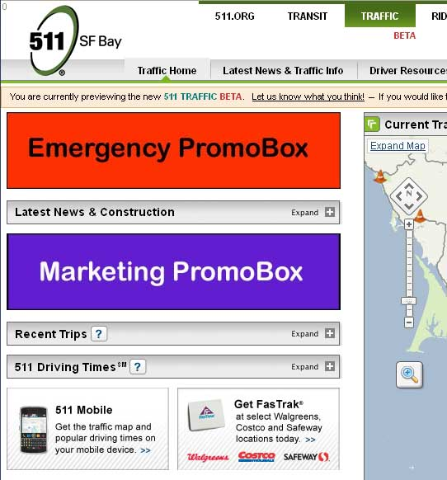
Generic promos
Each promo has an enabled flag, display order, and an optional start/stop date and time.
If there are more than two active promos of a given display type, only the first two will be displayed.

On the My511 website
Promo images appear in the sidebar on the main page.
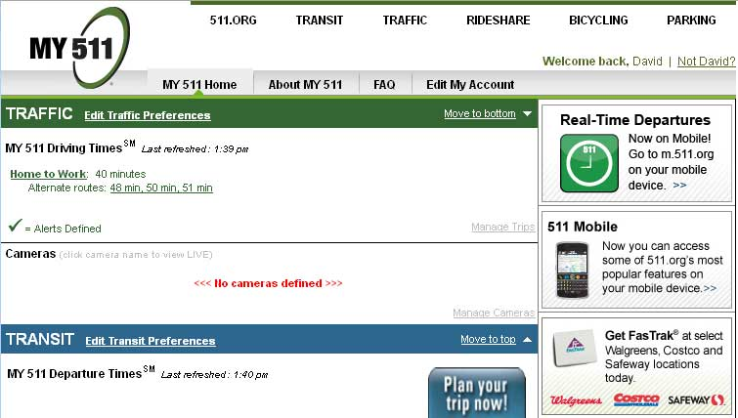

Database Changes and Data Format
The existing tblImageCatalog table in the MY511 database has been modified to add start/end date, enabled flag and display type columns. The same table has been created in the GlimpseWeb database for use by the Traffic website.
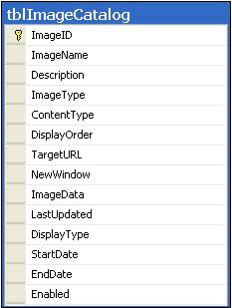

Traffic Promo image data is published in JSON format (grouped by DisplayType)
{
"Generic": [
{
"Description": "Get FasTrak",
"DisplayType": "Generic",
"ImageID": "45bb897b-f06c-4ed0-ab6e-4bd4cfcbd2e8",
"ImageName": "ImageName",
"NewWindow": true,
"TargetURL": "http://www.bayareafastrak.org/static/rts/rtslocations.shtml"
}
],
"Marketing": [],
"Emergency": []
}

Admin Site
http://localhost/511TrafficAdmin/Home.mvc

Authentication
Using Forms authentication with cookie expiration set to 48 hours (2880 minutes).
The existing AppUser table contains the username and hashed password. (there is currently no way to add/edit/delete users within the admin application).
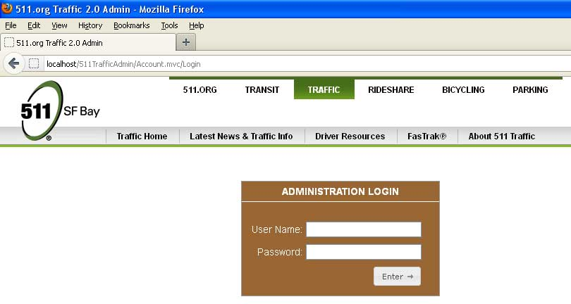

Admin Home Page
http://localhost/511TrafficAdmin/Home.mvc
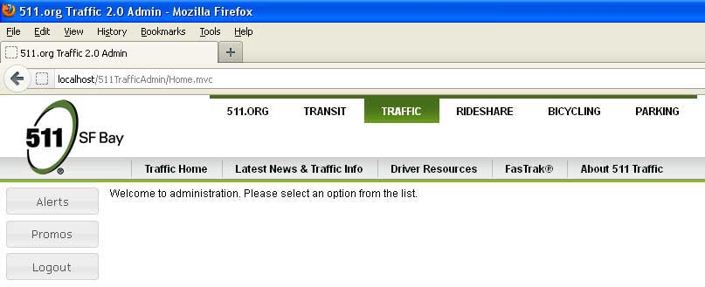
The Alerts section is under construction…

Promo Admin Page
http://localhost/511TrafficAdmin/Promo.mvc
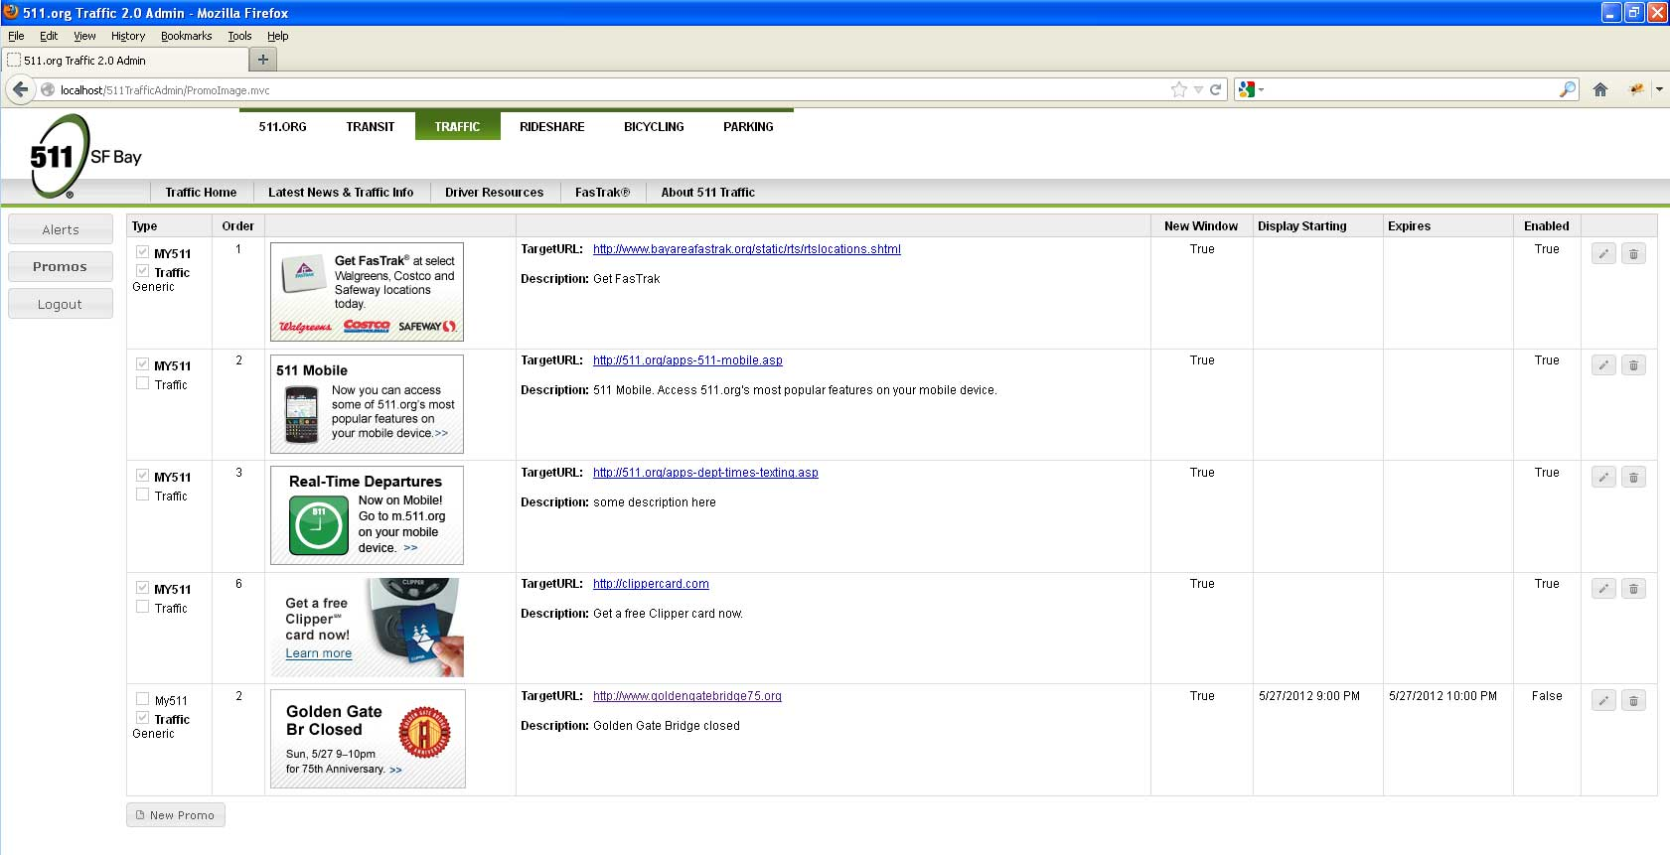

Adding a new Promo
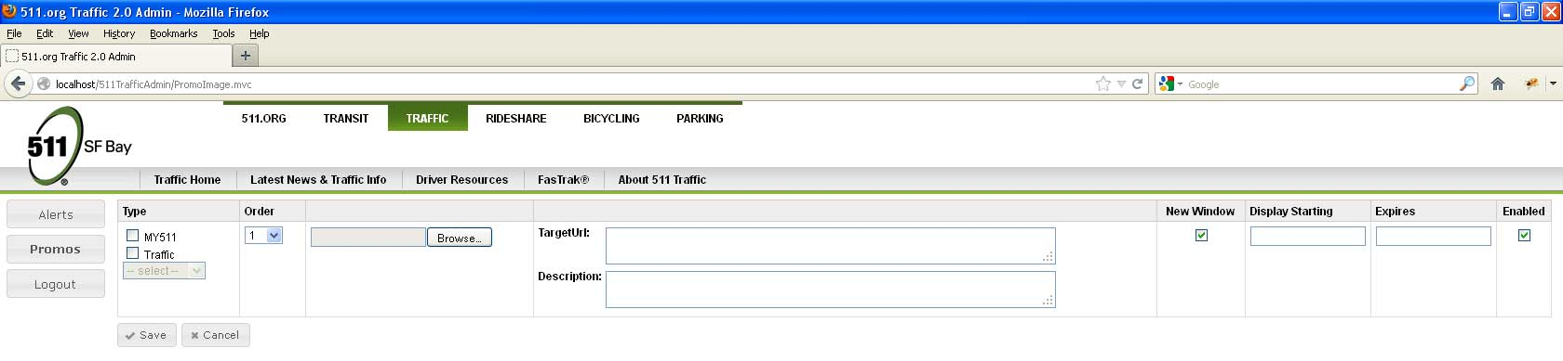
Select the Type checkboxes to indicate where the promo image will appear. If Traffic is selected, choose a category from the dropdown (either Emergency, Generic, or Marketing).
Click on the “Browse” button the open an image selection dialog.
Clicking on either “Display Starting” or “Expires” text fields will open the date/time selection dialog.
The promo is not saved until all required fields are completed and the “Save” button is clicked.
Once it has been successfully saved, the list of promos will be redisplayed showing the new promo.

Date/Time Selection
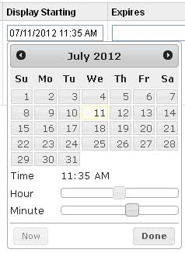
Since this is an optional field, you can leave it blank by selecting the date in the text field and pressing the delete key.

Editing a Promo
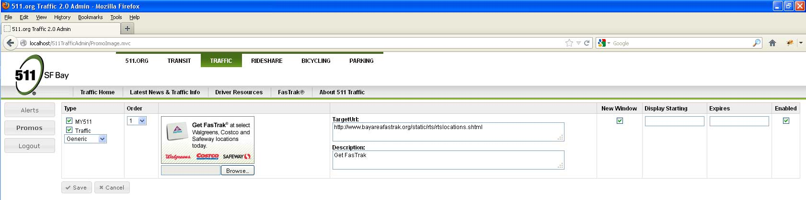
Same as “Adding a new Promo” above.
Once it has been successfully saved, the list of promos will be redisplayed showing the updated promo.

Deleting a Promo
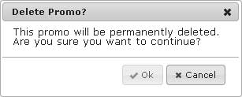
Hitting the escape key or closing the dialog will NOT delete the promo.
Once it has been successfully deleted, the list of promos will be redisplayed.

Loading images from the database

On the new Traffic website
Using /Utils.mvc/ShowPromoImage/<ImageID> to return the image bytes as a file of the selected ContentType. These are not currently cached. If the ImageID is not found, a “missing” image is returned:


On the My511 website
Using /RetrieveImage.aspx?imageId=<ImageID> to return the image bytes as a file of the selected ContentType. These are not currently cached.

Deployment

Database Scripts
http://vcs.lan.511.org/Repositories/TI_Prod/TI 511-Web/MY511/2.0/Database Scripts/Bug#1304.sql
http://vcs.lan.511.org/Repositories/TI_Prod/TI 511-Web/Traffic 2.0/Database/GlimseWeb/build.xml
http://vcs.lan.511.org/Repositories/TI_Prod/TI 511-Web/Traffic 2.0/Database/GlimseWeb/Source
- ImageCatalog.sql
- spGetActivePromoImages.sql
- spUpdatePromoImage.sql

Website installation and configuration

For the new TrafficAdmin website
TBD

In TrafficCore XML Config file
Add this connection string:
<Parameter Name="ConnectionStringMy511">
<Value>Data Source=trf-sql2;Initial Catalog=My511;Persist Security Info=true;User ID=sa;Password=$3agl3@$</Value>
<PrettyName>Connection String For My511</PrettyName>
<Description>
</Description>
</Parameter>

References
“Missing” image and upload icon from: http://findicons.com/icon/125416/upload

